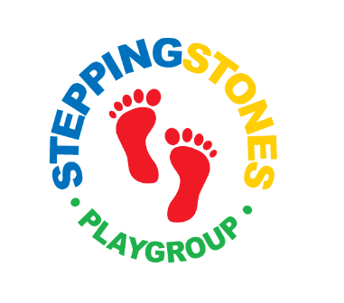
Staff Sickness Policy and Procedure

Statement of intent
Stepping Stones encourages all its employees to maximise their attendance at work while recognising that employees will, from time to time, be unable to come to work due to sickness.

By implementing this policy, we aim to strike a reasonable balance between the pursuit of it’s business needs and the genuine needs of employees to take occasional periods of time off work because of sickness. This policy and procedure establishes a framework to support individuals and the organisation in times of sickness absence. It ensures that appropriate and consistent advice is provided and that assistance and support is offered to employees and, where necessary, action is taken.

Absence: whether due to illness or any other circumstances is defined (for the purpose of this document) as the non-attendance of workers when they are contracted to attend.

Aims

We aim to provide a healthy working environment and demonstrate commitment to health, safety and the welfare of staff in order to maximise attendance.

Management are responsible for regularly monitoring and taking appropriate action in connection with sickness and other unplanned absence.

- Notification of absence from work owing to illness or any other cause should be made to Lauren Wilkinson by 8am by telephone on the first day of sickness. (A text message is not acceptable) giving a clear indication of the nature of the illness and a likely return date.
- Call by 2pm to let the manager know whether you are back to work or not for staff ratios for the following day.
- After an absence of five or more consecutive days due to sickness, a form for self-certification must be obtained, completed and sent to your employer.
- Subsequent Doctor’s statements must be submitted as often as required for State Benefit purposes. Dates on statements must follow consecutively.
- A final Doctor’s statement giving the date on which you will be fit to resume work will also be required.
- Employees will be paid sick pay in accordance with the Statutory Sick Pay Scheme (SSP).
- 5 consecutive days of illness – complete return to work form

Updated and implemented Autumn Term 2022 – reviewed regularly and the procedure monitored and evaluated.

